

TO BENEFIT THE P.G. Council #2809 GRAND KNIGHT CHARITIES
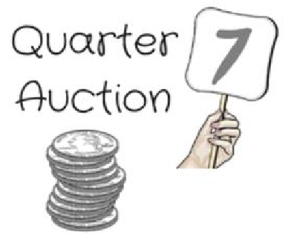

Saturday, November 7, 2026

Knights of Columbus, 9450 Cherry Hill Road, College Park, Maryland 20740

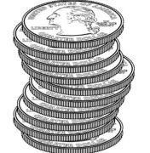
Doors & Kitchen Open at 2:00 pm
Auction at 3:00 pm (Vendors subject to change)

$15.00 Admission – includes 2 paddles, and one roll of quarters

Food/Beverages for purchase/50-50 Drawings/Raffles

Designer Purses Gift Cards ThirtyOne Gifts Scentsy
Tupperware Pamper Chef Cash Surprise Liquor and More..

How to Play:
- Each vendor will display items for bid for guests to see. When the auction begins, auctioneer gives a description, retail value, and how many quarters are needed to bid per item.
- If interested in the item, place bid in container on the table and hold up a numbered paddle.
- When all bids are collected, the auctioneer will draw a number. If the number on a raised paddle matches the number drawn then that person wins to choose any item on the table, You can win the item for just $.25, $.50, $.75 or $1.00.a number and that paddle is not raised another will be drawn until there is a winner,,
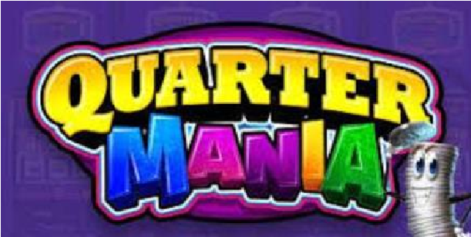
ROLLS of Quarters will be available at auction.

