

TO BENEFIT THE P.G. Council #2809

Aquaknights Swim Team & Club House



# Saturday, February 8, 2025

Knights of Columbus, 9450 Cherry Hill Road, College Park, Maryland 20740

Doors & Kitchen Open at 2:00 pm

Auction at 3:00 pm (Vendors subject to change)

$15.00 Admission – includes 2 paddles, and one roll of quarters

Food/Beverages for purchase/50-50 Drawings/Raffles

Designer Purses Gift Cards ThirtyOne Gifts Scentsy

Tupperware Pamper Chef Cash Surprise Liquor and More..

**How to Play:**

* **Each vendor will display items for bid for guests to see. When the auction begins, auctioneer gives a description, retail value, and how many quarters are needed to bid per item.**
* **If interested in the item, place bid in container on the table and hold up a numbered paddle.**
* **When all bids are collected, the auctioneer will draw a number. If the number on a raised paddle matches the number drawn then that person wins to choose any item on the table, You can win the item for just $.25, $.50, $.75 or $1.00.a number and that paddle is not raised another will be drawn until there is a winner,,**

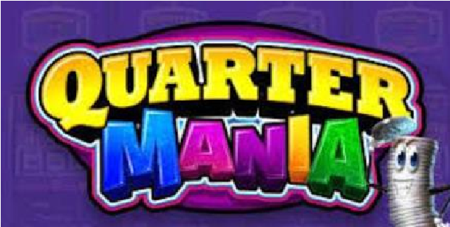  **ROLLS of Quarters will be available at auction.**