

Support AMJ Curley Assembly 383

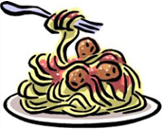**Family Fundraiser Night**

**COME JOIN US!**

**Mamma Lucia Restaurant will give 20% of sales with this flyer to our Assembly**

Mamma Lucia is an "Authentic Provincial Italian" restaurant located at 4734 Cherry Hill Road, College Park (in the shopping center with Shoppers and Home Depot)

**When: Wednesday, October 2, 2024**

**Time: 5:00 pm to 10:00 pm**

You can dine-in or carry-out and 20% of what you spend will go to enabling our works of charity:

(Little Sisters of the Poor, Laurel Pregnancy Center, Armed Forces Retirement Home, USO Kits, Wreaths Across America, Support for Priests/Religious)

