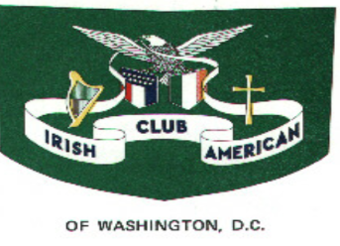

Happy St Patrick's Day Celebration

**Join the Irish American Club**

**For Dining and Dancing**

**Music by Sean Fleming**

**Menu: Ham Shepherd's Pie Peas Carrots Salad Rolls**

**Chicken Nuggets Cake Tea & Coffee**

**CASH BAR**

**Saturday March 4, 2023**

**Knights of Columbus Hall**

**10142 Cherry Hill Rd**

**College Park Md 20740**

**TICKETS MUST BE PAID IN ADVANCE BY FEBRUARY 19, 2023**

**NO TICKETS WILL BE SOLD AT THE DOOR**

**Tickets:**

**Adults $45.00 each**

**Kids ages 7-12 $20.00 each**

**Children 6 and under FREE**

**Tickets may be purchased online at**[**www.irishamericanclubdc.com**](http://www.irishamericanclubdc.com/)

**or by check payable to: Irish American Club**

**Mail to Theresa Cullinane**

**4114 10th Street N.E.**

**Washington D.C. 20017**

**For further information contact the club at**[**irishamericanclubdc@gmail.com**](mailto:irishamericanclubdc@gmail.com)

**or call 301 854-1318**