**St. Joseph Family Night**

**Please come out and support this Parish Fundraiser!**

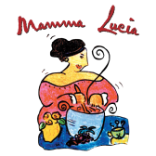

**Mamma Lucia Restaurant will give 20% of sales with this flyer to support**

**St. Joseph Church**

Mamma Lucia is an "Authentic Provincial Italian" restaurant located at 4734 Cherry Hill Road, College Park (Marketplace – next to Shoppers)

**When: Wednesday, December 1, 2021**

**Time: 4:00 pm to 9:00 pm**

You can dine-in or carry-out

20% of your bill will go directly to St. Joseph Catholic Church.