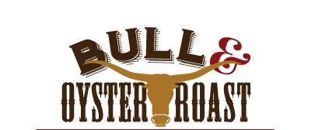

Sunday, September 25, 2022 • 2:00pm to 6:00pm

St Joseph Catholic Church and School

11011 Montgomery Road, Beltsville, MD 20705  
www.stjosephbeltsville.org

Advanced Ticket Sales Only, through September 11. $55/individual; $100/two.   
Tickets can be purchased after Masses, on our parish website  
or by contacting Liezl Argente liezlargente@gmail.com  
Must have a ticket to enter. Must be 21 and over to attend.  
Beer and Wine available for purchase.

Silent Auction • Sweepstakes • Wheel of Chance • 50/50 • Wine Pull

Proceeds to benefit the Mortgage Debt Reduction Fund.

Buffet Menu

Assorted raw vegetables, cheese, pepperoni, grapes, crackers, dips

Maryland Crab Soup

Fresh Shucked Oysters on the Half Shell, with lemons, Tabasco, cocktail sauce

Carving station with Top Rounds of Beef, Black Forest Ham, Smoked Turkey Breast

Fried Chicken

Parsley Buttered Potatoes

String Beans with Onions and Bacon

Italian Sausages with Onions and Roasted Peppers

Baked Ziti

Caesar Salad with Creamy Parmesan Dressing, Croutons, Parmesan

Italian Tomato Salad

Pretzels, Potato Chips

Assorted Iced Sheet Cakes